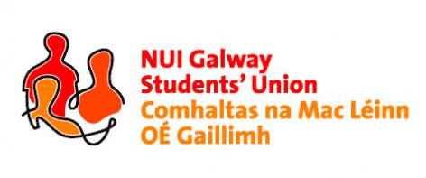

NUI, Galway Students’ Union Executive Meeting
8:00pm, Sunday, 18th October, 2015

Minutes*

Present: Phelim Kelly (President); Rebecca Melvin (Vice-President/Education); Jimmy McGovern (Vice-President/Welfare); Patrick O’Flaherty (Societies Chairperson); Cathal Sherlock (SU Council Chairperson); Jasmine Shaw (Arts Convenor); David Newell (Engineering Convenor); Cian Moran (Postgraduate Officer), Catherine Ryan (Equality Officer); Robert Forde (Mature Students Officer); Tara Ward (Science Convenor); Laoighseach Ní Choistealbha (Oifigeach na Gaeilge); Aoife Bell (Medicine, Nursing & Health Sciences Convenor); Niall Gaffney (Business, Public Policy & Law Convenor); Eoin Mangan (Clubs Captain).
Apologies:

Item Officer

- Minutes (President)
Phelim Kelly (President) apologised for not having the minutes prepared for the meeting but will get them in due course in time for the following meeting.

- Matters Arising (President)
No matters arose.

- Meeting with HEA re: Student Engagement (President)
Phelim gave a brief overview on the recent meeting with the HEA on student engagement. A long discussion ensued regarding student engagement in NUI Galway and it was genuinely felt amongst the executive committee that students are not consulted accurately as regards their learning or any academic policies etc. which come from the top down. Phelim, Rebecca, Jimmy and two post graduate reps attended the meeting. Both Jimmy and Rebecca feel the meeting was very productive and noted how receptive the committee were in engaging with the students. Phelim looks forward to seeing the report from this meeting.
- Anti-Bullying Campaign (President)
Phelim thanked Robert Forde (Mature Students Officer) for organising the anti-bullying meeting with the mature student’s society. The executive committee noted various points in the meeting and look forward to working on a campaign with the mature students. Phelim is to liaise with Student Services regarding orientation events and possible incorporating something on university open days. Catherine Ryan (Equality Officer) will also incorporate something mature students related in her rise above hate week.

- Any Other Business
No matters arose.

Meeting concluded.

Minutes proposed by: Phelim Kelly, President, NUI Galway Students’ Union

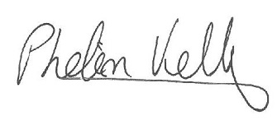

Seconded by:

01/11/2015

*These minutes were prepared from a contemporaneous note taken by Phelim Kelly (President) at the meeting of the 18th October, 2015, and were typed into this memorandum style document for the record of Council.

