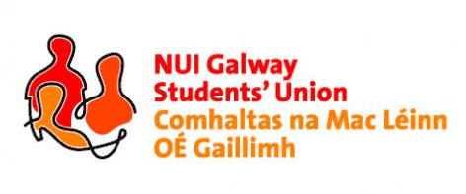

NUI, Galway Students’ Union Executive Meeting
8:00pm, Sunday, 28th February, 2016

Present: Rebecca Melvin (Vice-President/Education); Jimmy McGovern (Vice-President/Welfare); Patrick O’Flaherty (Societies Chairperson); Eoin Mangan (Clubs Captain); Robert Forde (Mature Students Officer); Cathal Sherlock (SU Council Chairperson); Jasmine Shaw (Arts Convenor); Niall Gaffney (Business, Public Policy & Law Convenor); Tim Murphy (Engineering Convenor); Cian Moran (Postgraduate Officer).
Apologies: Phelim Kelly (President); Catherine Ryan (Equality Officer).
Absent: Aoife Bell (Medicine, Nursing & Health Sciences Convenor), Laoighseach Ní Choistealbha (Oifigeach na Gaeilge); Tara Ward (Science Convenor).

Minutes*

Matters arising:
No matters arose.

Nominations for USI Elections Returning Officer:
Rebecca opened nominations for a Returning Officer for the USI Elections on Monday 29th February 2016. Phelim had suggested in his absence that Chris Newell would be nominated. The Executive Committee unanimously agreed with Chris Newell being appointed Returning Officer.

Discussion on increase in Exam Repeat Fees:
Rebecca read out a report regarding the Exam Repeat Fees. A long discussion with the Executive Committee was held regarding the increase in fees and what the Union can do to fight it. It was agreed that Cathal Sherlock (SU Council Chairperson) would include a motion at Class Rep Council on Monday 29th February and that a discussion with Class Reps could be had then. Phelim Kelly (President) had agreed at Údarás na hOllscoile on Friday that the President of NUI Galway, Dr. Jim Browne, would meet SU Council, however if he is unable to make it on Monday 29th February 2016, the Exec agreed that the Union should hold a Special Council for Dr Jim Browne.

SU Council:
Cathal Sherlock (SU Council Chairperson) thanked the executive committee for their reports in and mentioned that SU council will take place at 6pm on February 29th in IT250.

Class Rep Hoodies:
Rebecca asked if any officers knew any Class Reps who have not received their hoodies to let her know.

AOB:
No A.O.B. arouse.

Meeting concluded.

Minutes proposed by: Tim Murphy, Engineering and Informatics Convenor, NUI Galway Students’ Union

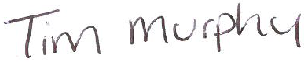

Seconded by:

[date]

*These minutes were prepared from a contemporaneous note taken by Tim Murphy (Engineering and Informatics Convenor) at the meeting of the 28th February, 2016, and were typed into this memorandum style document for the record of Council.

