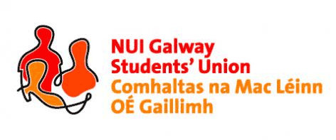

**Emergency Meeting Re: Students’ Union Charity Selection**

**NUI, Galway Students’ Union Executive Meeting**

***6:00pm, Wednesday, 16th September, 2015***

**\*Charity Nominations were sent to each officer through their SU and personal email accounts by Joanna Brophy a week prior to the meeting.**

***Minutes\****

***Present:*** *Phelim Kelly (President); Rebecca Melvin (Vice-President/Education); Jimmy McGovern (Vice-President/Welfare); Laoighseach Ní Choistealbha (Oifigeach na Gaeilge); Catherine Ryan (Equality Officer); Patrick O’Flaherty (Societies Chairperson); Eoin Mangan (Clubs Captain); Cian Moran (Postgraduate Officer); Robert Forde (Mature Students Officer); Cathal Sherlock (SU Council Chairperson); Jasmine Shaw (Arts Convenor); Tara Ward (Science Convenor); Aoife Bell (Medicine, Nursing & Health Sciences Convenor); Niall Gaffney (Business, Public Policy & Law Convenor); David Newell (Engineering Convenor).*

***Apologies:***

***Minutes\****

**Welcome:**

Phelim Kelly (President) welcomed and thanked the executive committee for their attendance to pick the SU charities. Phelim highlighted the importance of the charity selection and that each charity must be given a fair evaluation. The decision taken from the meeting will be final and Phelim asked that all officers participate in this process and to speak up if they want a particular charity to receive the funding from this year’s collections.

**Follow up Re: Postering policy breach:**

Phelim informed the executive committee that he has been in touch with the named business in relation to the breach in the university’s postering policy. The business sends its apologies and will ensure to have their promo team briefed in future. They will also make contact with Patrick O’Flaherty (Societies Chairperson) in relation to same. Phelim asked that should any cases like these arise in future to let him know so that it can be dealt with as he may not see them first hand.

**Future Executive Meetings:**

From the online poll, Phelim informed the executive committee that future executive meetings will take place every Sunday evening at 8pm. Phelim re-iterated that he did not want to have part time officers in particular to miss out on any club/society involvement due to their union commitments. Phelim asked that officers make every effort to be present for the meetings as per the union mandate in the constitution.

**Charity Selection:**

After a lengthy discussion around the charities, the Executive Committee voted via secret ballot on which charities NUI Galway Students’ Union would support for the academic year 2015-16

The charities selected are as follows:

Galway Rape Crisis Centre

***And***

Irish Cancer Society

Phelim thanked the executive committee for their participation in the selection of the charities and that the more important task of raising money for the charities will be key to every campaign this year.

Meeting concluded.

Minutes proposed by: Phelim Kelly, President, NUI Galway Students’ Union

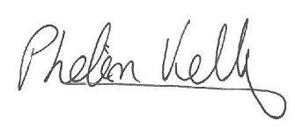

Seconded by:

**20/09/2015**

\**These minutes were prepared from a contemporaneous note taken by Phelim Kelly (President) at the meeting of the 16th September, 2015, and were typed into this memorandum style document for the record of Council*.