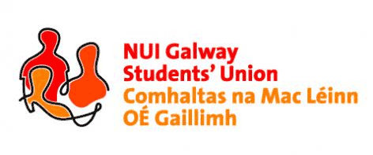

**NUI, Galway Students’ Union Executive Meeting**

***8:00pm, Sunday, 4th October, 2015***

***Minutes\****

***Present:*** *Phelim Kelly (President); Rebecca Melvin (Vice-President/Education); Jimmy McGovern (Vice-President/Welfare); Laoighseach Ní Choistealbha (Oifigeach na Gaeilge); Patrick O’Flaherty (Societies Chairperson); Eoin Mangan (Clubs Captain); Cathal Sherlock (SU Council Chairperson); Jasmine Shaw (Arts Convenor); Aoife Bell (Medicine, Nursing & Health Sciences Convenor); David Newell (Engineering Convenor); Niall Gaffney (Business, Public Policy & Law Convenor); Cian Moran (Postgraduate Officer).*

***Apologies:*** *Catherine Ryan (Equality Officer); Robert Forde (Mature Students Officer); Tara Ward (Science Convenor).*

***Item Officer***

1. **Minutes (President)**

The minutes of meeting 4 27/09/2015 were taken as a true and accurate record of same. Phelim Kelly (President) will have the minutes put up on the SU website.

1. **Matters Arising (President)**

Aoife Bell (Convenor of Medicine, Nursing & Health Sciences) asked for an update regarding the microwaves north campus. Phelim Kelly (President) has asked to meet with Dean Pierce from the buildings office and as such has no update at this time. Phelim will report with an update in due course.

1. **Residence Runs (President)**

Phelim asked the executive committee to help out the following week in terms of residence runs around local residences where students are mixed with locals. Due to several complaints with the Woodquay residential association, they will take priority. If the numbers are there, Hazel Park will also be done on the same night. The executive committee agreed the importance and will help out with the SU volunteering crew.

1. **Voter Registration (President)**

Phelim has organised a voter registration day for Thursday October 8th and asked that all of the executive committee to take part and register as many people as possible to vote for the upcoming general elections. Feidhlím Seoighe, Annie Hoey and Daniel Waugh from USI Officer Board will also be there on the day to help.

1. **Class Reps (President)**

Rebecca Melvin (VP Education) thanks all the executive committee for their help re rep elections. She will get in touch with the relevant convenors to make sure all reps are elected in due course.

1. **Officer Reports for SU Council (SU Chairperson)**

Cathal Sherlock (SU Council Chairperson) asked that all officers submit their reports be in for Wednesday October 7th before 5pm.

Meeting concluded.

Minutes proposed by: Phelim Kelly, President, NUI Galway Students’ Union

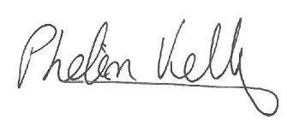

Seconded by:

**11/10/2015**

\**These minutes were prepared from a contemporaneous note taken by Phelim Kelly (President) at the meeting of the 4th October, 2015, and were typed into this memorandum style document for the record of Council*.