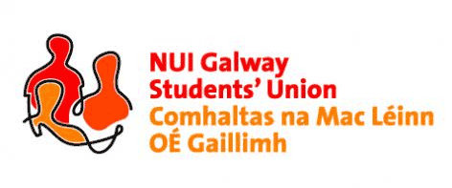

**NUI, Galway Students’ Union Executive Meeting**

***8:00pm, Sunday, 8th November, 2015***

***Present:*** *Phelim Kelly (President); Rebecca Melvin (Vice-President/Education); Jimmy McGovern (Vice-President/Welfare); Laoighseach Ní Choistealbha (Oifigeach na Gaeilge); Catherine Ryan (Equality Officer); Patrick O’Flaherty (Societies Chairperson); Eoin Mangan (Clubs Captain); Robert Forde (Mature Students Officer); Cathal Sherlock (SU Council Chairperson); Jasmine Shaw (Arts Convenor); Aoife Bell (Medicine, Nursing & Health Sciences Convenor); Niall Gaffney (Business, Public Policy & Law Convenor).*

***Apologies:*** *David Newell (Engineering Convenor); Cian Moran (Postgraduate Officer); Tara Ward (Science Convenor).*

***Minutes\****

**Minutes:**

Phelim Kelly (President) proposed the minutes of the previous meeting. The minutes were taken as a true and accurate reflection of the previous meeting. Phelim will have them put on the SU website in due course.

**Matters Arising:**

No matters arose.

**Future Executive Meetings:**

A discussion ensued around the timing of the executive committee meetings. It was decided to keep them at the current time and revisit the idea in semester 2 once the executive committee has their timetables.

**Mature Students Convention:**

Robert Forde (Mature Students Officer) gave the executive committee an overview of the event and thanked Cathal Sherlock (SU Council Chair) for attending. Robert took a lot of positives from the event and thanked Phelim for organising the bus. Robert expressed concern over the lack of attendance from the mature students’ society and felt that the bus was not needed as a result. Phelim expressed his dissatisfaction that people did not turn up when such a thing was organised but said that at least the option was there to go. Phelim will liaise with the Mature Students society and convey this message.

**Postgrad Open Day:**

Phelim and Catherine Ryan (Equality Officer) met with Dr Micheline Sheehy Skeffington regarding the gender equality campaign. Micheline has asked that the Students’ Union would organise volunteers for leafleting the Postgraduate Open Day. Phelim has informed Micheline that the Union will help out and will print some flyers for the day. Phelim asked that all available executive committee members would help out on the day with leafleting. Phelim also informed the executive committee of a gender conference taking place on December 4th. Details of the event are still to be confirmed and he will keep the executive committee posted on any developments.

**White Collar Boxing NUIG Vs. GMIT:**

Niall Gaffney (Business, Public Policy & Law Convenor) would like to run a white collar boxing night in aid of the SU charities. Phelim advised him to speak with Dave King (Head of Security College Bar) who was involved in the previous event. Niall will make contact with Dave and keep the executive posted on any developments.

**Student Health Unit:**

Aoife Bell (Convenor of Medicine, Nursing & Health Sciences) raised concerns over the use of Mantoux tests. These are given to students going into clinical practice. Aoife went into detail around the validity of the test which tests for an immune response to tuberculosis. There is also concerns over documentation not being accepted by the SHU which clearly states whether or not one has received a vaccine. Phelim advised Aoife to speak with Dr. Idina Moylett (Head of Student Affairs in the College of Medicine) who may be able to bring this further. Aoife will keep the executive committee posted for any developments.

**Anti-Bullying Campaign:**

Aoife would like to run the campaign on week one of second semester. A discussion ensued around materials and campaign ideas. Phelim asked that a slogan for the campaign be brought to him asap so that the wristbands can be ordered. A number of the executive committee will meet to brainstorm ideas in hopes to getting material ready for design and print.

**Water Cooler at reading room:**

Jasmine Shaw (Convenor of Arts) raised concerns over the cooler from the reading room being taken away and that several Arts students have brought this to her attention. Phelim will look into the matter with buildings and find out why that was taken away and will endeavour to have it replaced. Phelim also informed the executive committee that he met with the commercial office in the university in hopes to have a microwave put into Zinc.

Meeting concluded.

Minutes proposed by: Phelim Kelly, President, NUI Galway Students’ Union

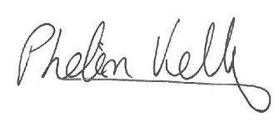

Seconded by:

**15/11/2015**

\**These minutes were prepared from a contemporaneous note taken by Phelim Kelly (President) at the meeting of the 8th November, 2015, and were typed into this memorandum style document for the record of Council*.