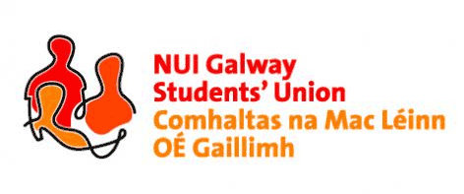

**NUI, Galway Students’ Union Executive Meeting**

***8:00pm, Sunday, 15th November, 2015***

***Present:*** *Phelim Kelly (President); Rebecca Melvin (Vice-President/Education); Jimmy McGovern (Vice-President/Welfare); Laoighseach Ní Choistealbha (Oifigeach na Gaeilge); Catherine Ryan (Equality Officer); Patrick O’Flaherty (Societies Chairperson); Eoin Mangan (Clubs Captain); Robert Forde (Mature Students Officer); Cathal Sherlock (SU Council Chairperson); Jasmine Shaw (Arts Convenor); Niall Gaffney (Business, Public Policy & Law Convenor); David Newell (Engineering Convenor); Cian Moran (Postgraduate Officer); Tara Ward (Science Convenor).*

***Apologies:*** *Aoife Bell (Medicine, Nursing & Health Sciences Convenor).*

*-Meeting commenced in the NUI Galway Quadrangle for the light up to show solidarity with the victims in the Paris attacks.-*

***Minutes\****

**Minutes:**

Phelim Kelly (President) apologised for not having the minutes ready for the meeting and will have the minutes of same along with the minutes for both meetings ready for the next meeting.

**Matters Arising:**

No matters arose.

**USI Pink Training:**

Phelim informed the executive of the great success of the event. Positive feedback was received regarding the event and he also thanked the executive committee who volunteered at the event. Phelim asked for general feedback on what the Students’ Union can take from it to NUI Galway. Laoighseach Ní Choistealbha (Oifigeach na Gaeilge) said she was amazed by the event and what it endeavours to do. She noted some of the Transgender workshops she believes can be brought to NUI Galway. Phelim re-iterated that point and will work with GiG Soc on an event plan for future hosts to deal with.

**SU Council:**

Cathal Sherlock (SU Council Chairperson) asked that the executive committee would get their officer reports in for the SU council which takes place on November 23rd in IT250. Cathal would like the reports earlier this time.

**Upcoming SU Events:**

Phelim informed the executive committee about the upcoming charity fundraiser Christmas day. Volunteers are needed for the event. Phelim will put a post on the Executive committee Facebook group where all officers need to respond. Phelim highlighted that this is the largest charity fundraiser for the entire year and that he will need as much volunteers as possible.

**USI General Election 15 Launch:**

Phelim asked if anyone from the executive committee would be available to attend a launch for the national Students’ Unions general election manifesto launch. Rebecca Melvin (VP/Education) and Catherine Ryan (Equality Officer) will attend along with a class rep. All members of the executive are welcome to attend as there will also be a networking event after with the other part time officers from around the country.

**Don’t Stress Impress:**

Rebecca gave an overview of the events which will take place throughout the week. She will also be providing workshops on procrastination, managing stress etc. there will also be an info stand each day at Smokies on subject choices, capped repeats etc.

Meeting concluded.

Minutes proposed by: Phelim Kelly, President, NUI Galway Students’ Union

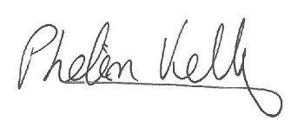

Seconded by:

**10/01/2016**

\**These minutes were prepared from a contemporaneous note taken by Phelim Kelly (President) at the meeting of the 15th November, 2015, and were typed into this memorandum style document for the record of Council*.