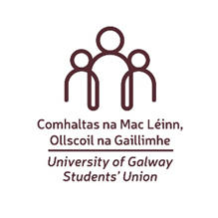

University of Galway Students’ Union Charity Fund Application Form 2026/27

Your contact details
First name: | Surname:
Occupation/role:

Organisation Name & CHY Number:
Phone & Email:

Application Details

1. Please give a brief description of what your money would go towards. (Max 150 words)
2. Where will the activities take place? How many people will benefit as a result? (Max 100 words)

3. Will you receive any external support for your project (financial or other)? (Max 50 words)

Please return this form before 17:00 Wednesday 26th of August to Joanna Brophy, Assistant Manager, University of Galway Students’ Union by Word Document e-mail only to joanna.brophy@universityofgalway.ie

Please do not include images in your application.
Canvassing will automatically disqualify.

